# WEBSITE FOR CLIENTS

(Report)

A PROJECT REPORT ON

### “MAKEUP MISTRESS WEBSITE”

**Developed by Haris Anwer**

**TABLE OF CONTENT**

Abstract ------------------------------------------------------------------------------------------Page no-4

Introduction -------------------------------------------------------------------------------------Page no 5

Motivation----------------------------------------------------------------------------------------Page no 5

Aim of Proposed Project -----------------------------------------------------------------------Page no 5

Tool/Software & Language Description ---------------------------------------------------- Page no 5-7

Project Model Diagram ------------------------------------------------------------------------Page no-7

Features and Project Modules-----------------------------------------------------------------Page no-7-8

* ADMIN SIDE-
* CUSTOMER SIDE

Database Snapshots-----------------------------------------------------------------------------Page no 9

GUI Snapshots----------------------------------------------------------------------------------Page no 10-16

Coding--------------------------------------------------------------------------------------------Page no 17-20

**Abstract**

Makeup Mistress website for selling products is process of doing business through computer networks. A person sitting on his chair in front of a computer can access all the facilities of the Internet to buy or sell the products.

Unlike traditional commerce that is carried out physically with effort of a person to go & get products, it has made it easier for human to reduce physical work and to save time. E-Commerce which was started in early 1990’s has taken a great leap in the world of computers, but the fact that has hindered the growth of this website is security. Security is the challenge facing e-commerce today & there is still a lot of advancement made in the field of security.

The main advantage of e-commerce over traditional commerce is the user can browse online shops, compare prices and order merchandise sitting at home on their PC.

**INTRODUCTION**

The consumer moves through the internet to the merchant's web site. From there, he decides that he wants to purchase something, so he is moved to the online transaction server, where all of the information he gives is encrypted. Once he has placed his order, the information moves through a private gateway to a Processing Network. This generally takes place in no more than 5-7seconds. There are many different payment systems available to accommodate the varied processing needs of merchants, from those who have a few orders a day to those who process thousands of  transactions daily. With the addition of Secure Layer Technology, Makeup Mistress is also a very safe way to complete transactions. We have build a website using ASP.net plate form. Database has been managed where all records can be fetched and saved.

**MOTIVATION**

In order to make the online shopping experience even more better, there are a lot of new technologies like Verifi and Touch Sense that have emerged over the last couple of years. Even though Touch Sense is very new technology and they haven't been adopted by the majority of internet shoppers yet, they promise a consumer-friendly future. Verifi is one technology that has been widely adopted today, and for good reason. According to a recent Biz Rate study, over 50% of online shoppers stated that they would not make further purchases from a Web merchant that delivered an item in a color that wasn't what they expected. So the real motivation is that to build a website where a consumer can easily buy customized product. To record all the data customers add and all data about products must be recorded.

**AIM OF PROPOSED PROJECT**

### Aim of project is to build a site where user can check contact, about, upcoming features, products and beauty products. This id for those girls and boys who are interested to buy beauty care customized products within reasonable price. As well as can contact the admin can send feedbacks. Admin can entertain feedbacks, booked orders, can manage registered users information. This is to make easy to use makeup selling corner where a lay man can also book their order. Aesthetics and contents are the king for this website. Navigations are also added in this website so the user can go deeper into options. To record all the data customers add and all data about products must be recorded.

**Tools/Software & Language Description**

* **Visual Studio 2013**

Microsoft Visual Studio is an integrated development environment (IDE) from Microsoft. It is used to develop [computer programs](https://en.wikipedia.org/wiki/Computer_program), as well as [websites](https://en.wikipedia.org/wiki/Web_site), [web apps](https://en.wikipedia.org/wiki/Web_app), [web services](https://en.wikipedia.org/wiki/Web_service) and [mobile apps](https://en.wikipedia.org/wiki/Mobile_app). Visual Studio uses Microsoft software development platforms such as [Windows API](https://en.wikipedia.org/wiki/Windows_API), [Windows Forms](https://en.wikipedia.org/wiki/Windows_Forms), [Windows Presentation Foundation](https://en.wikipedia.org/wiki/Windows_Presentation_Foundation), [Windows Store](https://en.wikipedia.org/wiki/Windows_Store) and [Microsoft Silverlight](https://en.wikipedia.org/wiki/Microsoft_Silverlight). It can produce both [native code](https://en.wikipedia.org/wiki/Machine_code) and [managed code](https://en.wikipedia.org/wiki/Managed_code).

Visual Studio includes a [code editor](https://en.wikipedia.org/wiki/Code_editor) supporting [IntelliSense](https://en.wikipedia.org/wiki/IntelliSense) (the [code completion](https://en.wikipedia.org/wiki/Code_completion) component) as well as [code refactoring](https://en.wikipedia.org/wiki/Code_refactoring). [The integrated debugger](https://en.wikipedia.org/wiki/Microsoft_Visual_Studio_Debugger) works both as a source-level debugger and a machine-level debugger. Other built-in tools include a [code profiler](https://en.wikipedia.org/wiki/Profiling_(computer_programming)), forms designer for building

[GUI](https://en.wikipedia.org/wiki/GUI) applications, [web designer](https://en.wikipedia.org/wiki/Web_designer), [class](https://en.wikipedia.org/wiki/Class_(computing)) designer, and [database schema](https://en.wikipedia.org/wiki/Database_schema) designer. It accepts plug-ins that enhance the functionality at almost every level.

* **ASP.net**

ASP.NET is an [open-source](https://en.wikipedia.org/wiki/Open-source_software)[[2]](https://en.wikipedia.org/wiki/ASP.NET#cite_note-2) [server-side](https://en.wikipedia.org/wiki/Server-side_scripting) [web application framework](https://en.wikipedia.org/wiki/Web_application_framework) designed for [web development](https://en.wikipedia.org/wiki/Web_development) to produce [dynamic web pages](https://en.wikipedia.org/wiki/Dynamic_web_page). It was developed by [Microsoft](https://en.wikipedia.org/wiki/Microsoft) to allow [programmers](https://en.wikipedia.org/wiki/Programmer) to build dynamic [web sites](https://en.wikipedia.org/wiki/Web_site), [web applications](https://en.wikipedia.org/wiki/Web_application) and [web services](https://en.wikipedia.org/wiki/Web_service). It was first released in January 2002 with version 1.0 of the [.NET Framework](https://en.wikipedia.org/wiki/.NET_Framework), and is the successor to Microsoft's [Active Server Pages](https://en.wikipedia.org/wiki/Active_Server_Pages) (ASP) technology. ASP.NET is built on the [Common Language Runtime](https://en.wikipedia.org/wiki/Common_Language_Runtime) (CLR), allowing programmers to write ASP.NET code using any supported [.NET language](https://en.wikipedia.org/wiki/List_of_CLI_languages). The ASP.NET [SOAP](https://en.wikipedia.org/wiki/SOAP) extension framework allows ASP.NET components to process SOAP messages.

* **MVC**

Model–View–Controller (usually known as MVC) is an [architectural pattern](https://en.wikipedia.org/wiki/Architectural_pattern) commonly used for developing [user interfaces](https://en.wikipedia.org/wiki/User_interface) that divides an application into three interconnected parts. This is done to separate internal representations of information from the ways information is presented to and accepted from the user. The MVC design pattern decouples these major components allowing for efficient [code reuse](https://en.wikipedia.org/wiki/Code_reuse) and parallel development.

Traditionally used for desktop [graphical user interfaces](https://en.wikipedia.org/wiki/Graphical_user_interface) (GUIs), this architecture has become popular for designing [web applications](https://en.wikipedia.org/wiki/Web_application). Popular programming languages like [Java](https://en.wikipedia.org/wiki/Java_(programming_language)), [C#](https://en.wikipedia.org/wiki/C_Sharp_(programming_language)), [Python](https://en.wikipedia.org/wiki/Python_(programming_language)), [Ruby](https://en.wikipedia.org/wiki/Ruby_(programming_language)), and [PHP](https://en.wikipedia.org/wiki/PHP) have MVC frameworks that are used in web application development straight [out of the box](https://en.wikipedia.org/wiki/Out_of_the_box_(feature)).

* **Html**

Hypertext Markup Language (HTML) is the standard [markup language](https://en.wikipedia.org/wiki/Markup_language) for creating [web pages](https://en.wikipedia.org/wiki/Web_page) and [web applications](https://en.wikipedia.org/wiki/Web_application). With [Cascading Style Sheets](https://en.wikipedia.org/wiki/Cascading_Style_Sheets) (CSS) and [JavaScript](https://en.wikipedia.org/wiki/JavaScript), it forms a triad of [cornerstone](https://en.wikipedia.org/wiki/Cornerstone) technologies for the [World Wide Web](https://en.wikipedia.org/wiki/World_Wide_Web). [Web browsers](https://en.wikipedia.org/wiki/Web_browser) receive HTML documents from a [web server](https://en.wikipedia.org/wiki/Web_server) or from local storage and [render](https://en.wikipedia.org/wiki/Browser_engine) the documents into multimedia web pages. HTML describes the structure of a web page [semantically](https://en.wikipedia.org/wiki/Semantic_Web) and originally included cues for the appearance of the document.

* **Bootstrap**

Bootstrap is a [free and open-source](https://en.wikipedia.org/wiki/Free_and_open-source) [CSS framework](https://en.wikipedia.org/wiki/CSS_framework) directed at responsive, mobile-first [front-end web development](https://en.wikipedia.org/wiki/Front-end_web_development). It contains [CSS](https://en.wikipedia.org/wiki/CSS)- and (optionally) [JavaScript](https://en.wikipedia.org/wiki/JavaScript)-based design templates for [typography](https://en.wikipedia.org/wiki/Web_design#Typography), [forms](https://en.wikipedia.org/wiki/Form_(HTML)), [buttons](https://en.wikipedia.org/wiki/Button_(computing)#HTML), [navigation](https://en.wikipedia.org/wiki/Web_navigation#Local_website_navigation) and other interface components. Bootstrap is the third-most-starred project on [GitHub](https://en.wikipedia.org/wiki/GitHub), with more than 131,000 stars, behind only [free Code Camp](https://en.wikipedia.org/wiki/FreeCodeCamp) (almost 300,000 stars) and marginally behind [Vue.js](https://en.wikipedia.org/wiki/Vue.js" \o "Vue.js) framework.

* **JavaScript**

JavaScript often abbreviated as JS, is a [high-level](https://en.wikipedia.org/wiki/High-level_programming_language), [interpreted](https://en.wikipedia.org/wiki/Interpreted_language) [programming language](https://en.wikipedia.org/wiki/Programming_language) that conforms to the [ECMAScript](https://en.wikipedia.org/wiki/ECMAScript) specification. JavaScript has [curly-bracket syntax](https://en.wikipedia.org/wiki/List_of_programming_languages_by_type#Curly-bracket_languages), [dynamic typing](https://en.wikipedia.org/wiki/Dynamic_programming_language), [prototype-based](https://en.wikipedia.org/wiki/Prototype-based_programming) [object-orientation](https://en.wikipedia.org/wiki/Object-oriented_programming), and [first-class functions](https://en.wikipedia.org/wiki/First-class_function). Alongside [HTML](https://en.wikipedia.org/wiki/HTML) and [CSS](https://en.wikipedia.org/wiki/CSS), JavaScript is one of the core technologies of the [World Wide Web](https://en.wikipedia.org/wiki/World_Wide_Web). JavaScript enables interactive [web pages](https://en.wikipedia.org/wiki/Web_page) and is an essential part of [web applications](https://en.wikipedia.org/wiki/Web_application). The vast majority of [websites](https://en.wikipedia.org/wiki/Website) use it,[[10]](https://en.wikipedia.org/wiki/JavaScript#cite_note-deployedstats-10) and major [web browsers](https://en.wikipedia.org/wiki/Web_browser) have a dedicated [JavaScript engine](https://en.wikipedia.org/wiki/JavaScript_engine) to execute it.

* **SQL server 2015**

Microsoft SQL Server is a [relational database management system](https://en.wikipedia.org/wiki/Relational_database_management_system) developed by [Microsoft](https://en.wikipedia.org/wiki/Microsoft). As a [database server](https://en.wikipedia.org/wiki/Database_server), it is a [software product](https://en.wikipedia.org/wiki/Software_product) with the primary function of storing and retrieving data as requested by other [software applications](https://en.wikipedia.org/wiki/Software_application)—which may run either on the same computer or on another computer across a network (including the Internet).

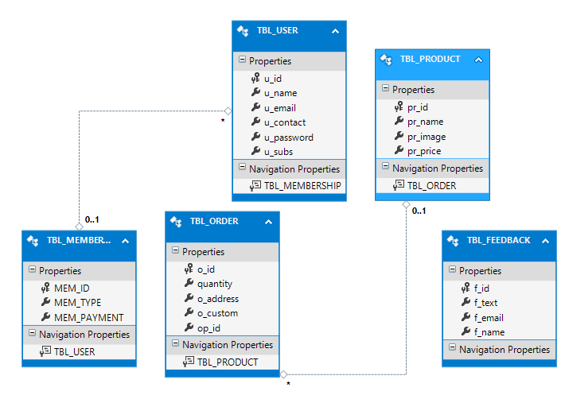**PROJECT MODEL DIAGRAM**

**FEATURES & PROJECT MODULES**

**CUSTOMER SIDE**

* **register**

user can register himself by submitting name, email, contact information, password and subscription type. once he get register, he will be able to login and book the order. it is dynamic page

* **login**

user have to provide validated email address and matching password which is saved in SQL database. if both of them found correct, user will move to logged in state, otherwise error message will be generated. it is also a dynamic page.

* **about**

about is our static page which will provide information to new users about our website. html, bootstrap is used to make it more attractive.

* **contacts**

without got logged in user can check contact information. it is purely static page for user welfare and authentication purposes.

* **check products**

without signing in user can view available products. it is dynamic as well as static. because designing is used to make it static where as products information are fetching from SQL database.

* **gallery**

gallery shows about our collection about photography, this service will be offered in future. it is purely static.

* **feedbacks**

feedbacks can be provided by registered users or visitors. it is dynamic page user can send feedbacks or suggestions to admin.

* **blogs**

blogs providing additional information about sponsors and other company’s bloggers reviews. it is static page.

* **fitness tips**

as this is makeup mistress website for beauty, fitness is the key point, it provides information to users about fitness tips and the fitness programs. it is static.

* **order**

once the user is logged in, he can order the available products. it is dynamic because all products are fetching out from SQL database and booked orders are getting recorded in database.

* **Sign out**

sign out will ultimately expire the logged in session of user. and order option will disappear from navigation.

**ADMIN SIDE**

* **view feedbacks**

admin can view the suggestions and feedbacks of users. it is dynamic because feedbacks are getting fetched from SQL table. it also provides options to admin about edit, delete or update.

* **manage customer records**

records about registered users will be managed by admin. it is dynamic.

* **add products**

it allows admin to add products dynamically which will then show on customer side.

* **view orders**

admin can view customers orders, to get ready for delivering them.

**DATABASE SNAPSHOTS**

* 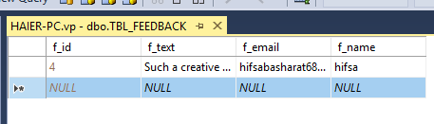**Tbl_Feedback**
* **Tbl_Membership**

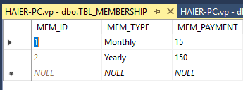

* **Tbl_Order**

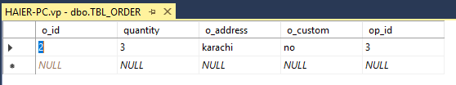

* **Tbl_Product**

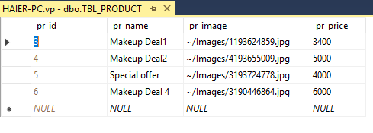

* 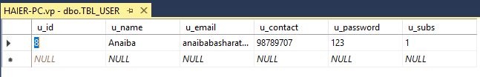**Tbl_User**

**GUI SNAPSHOTS**

**ADMIN SIDE**

* 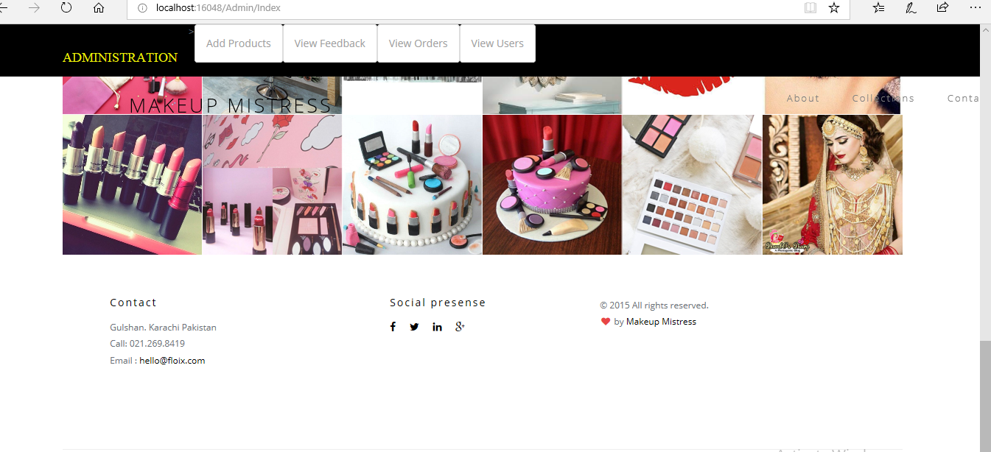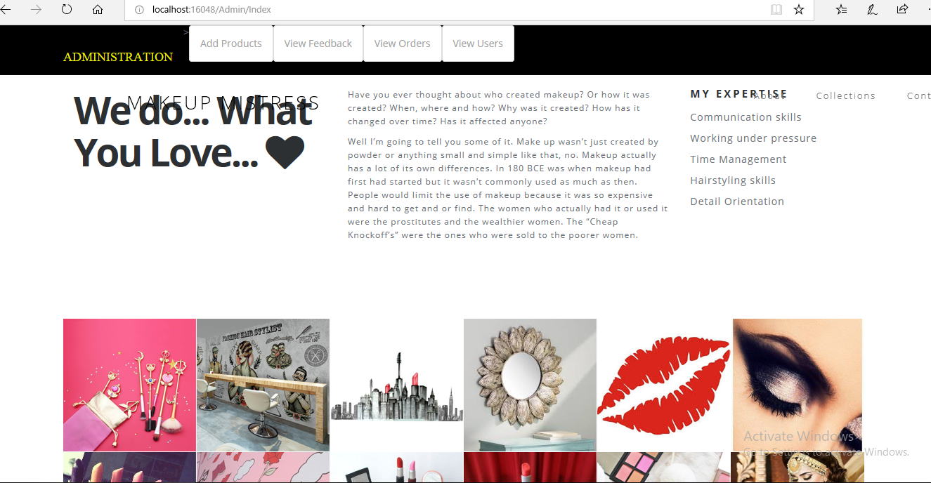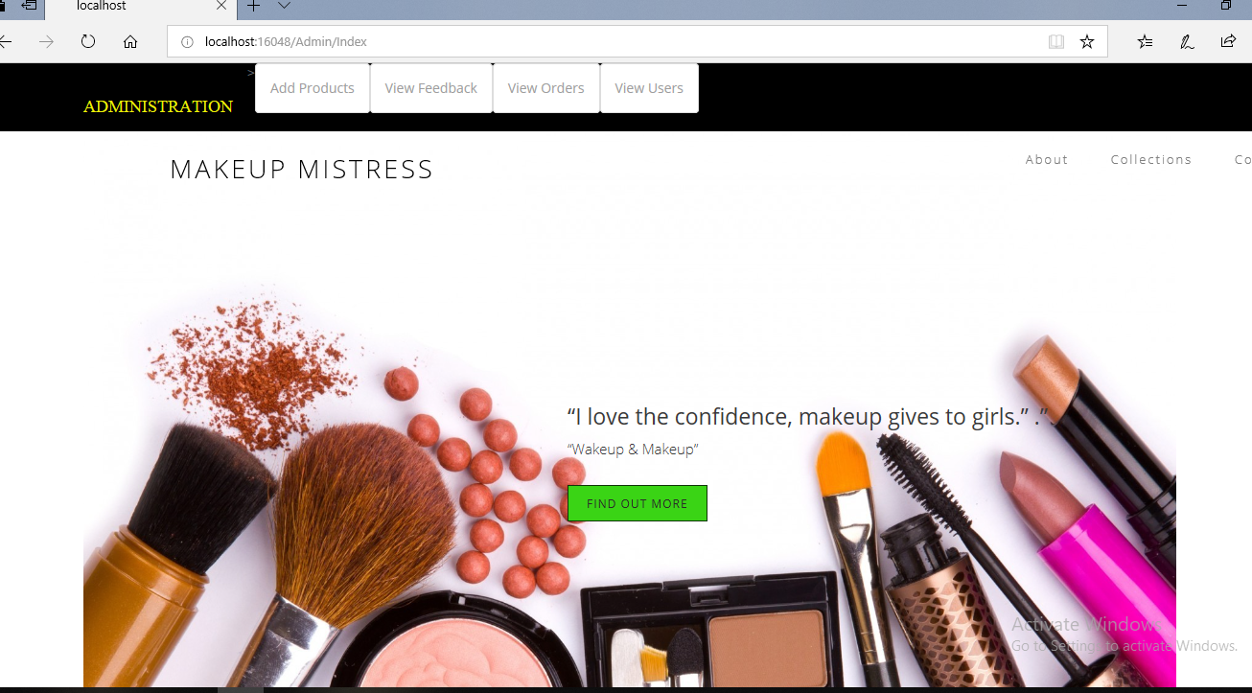**admin index**
* 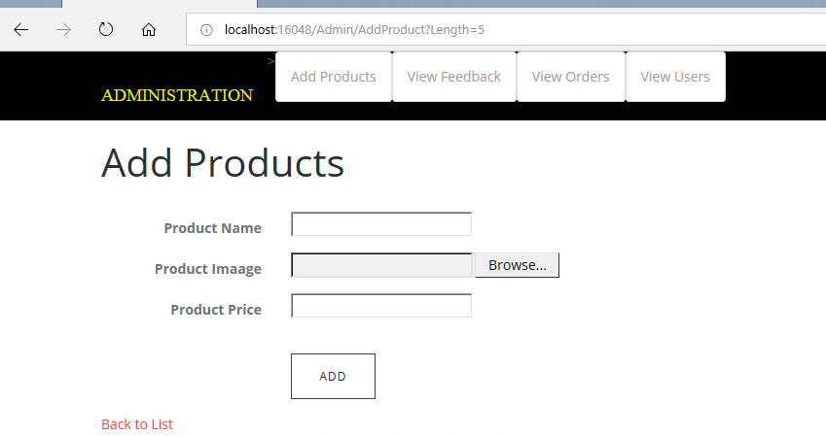**add products:**
* 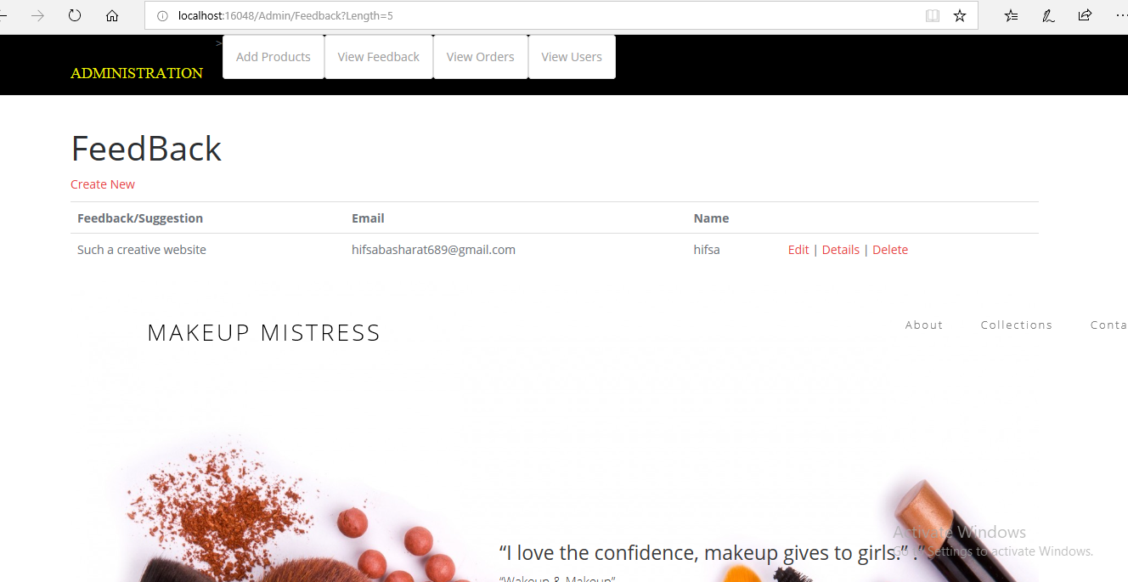**view feedbacks**
* 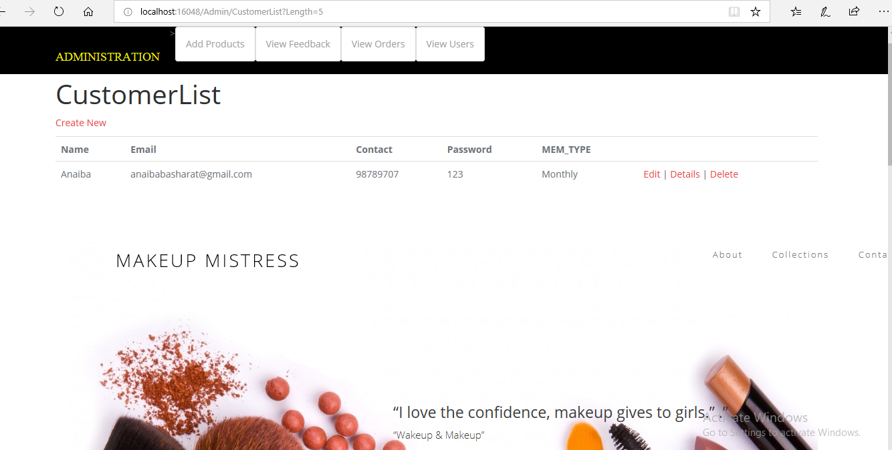**manage users**
* **view orders**

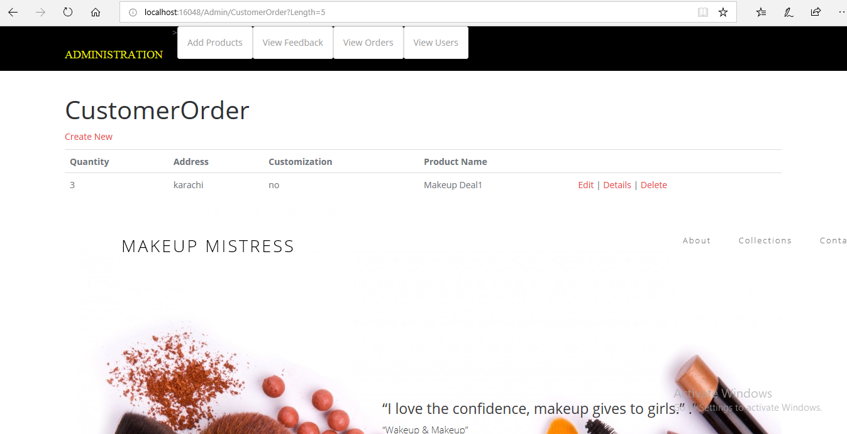

**CUSTOMER SIDE:**

* 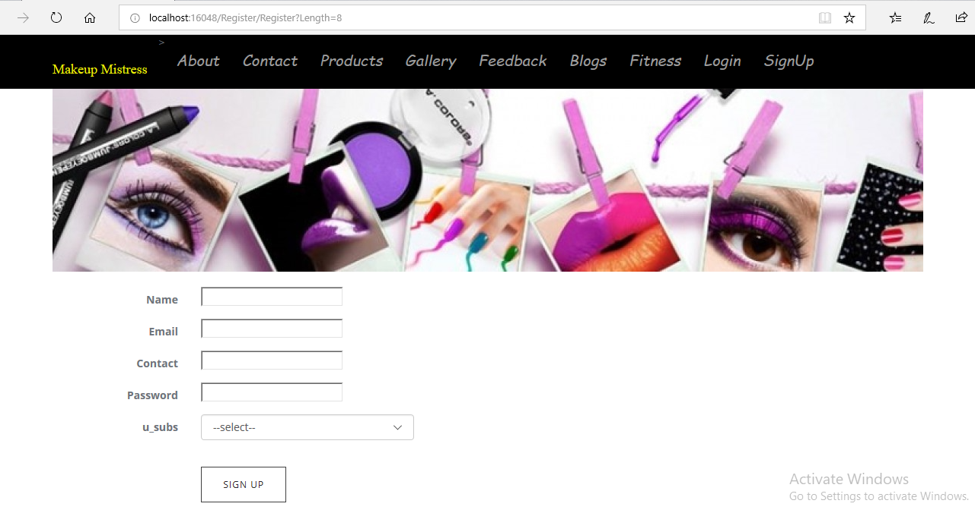**signup**
* 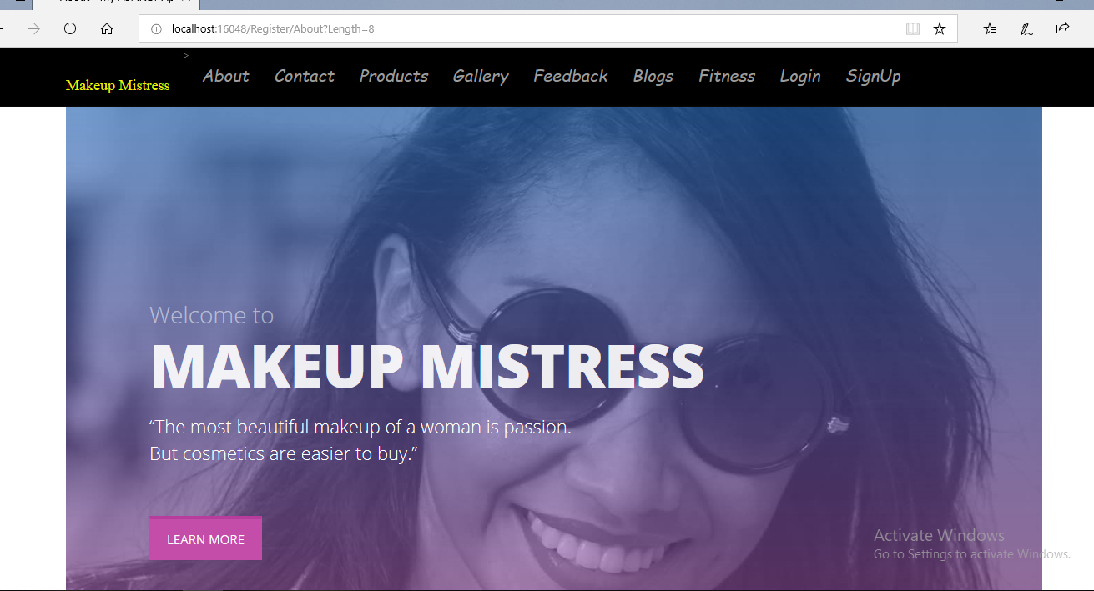**about**

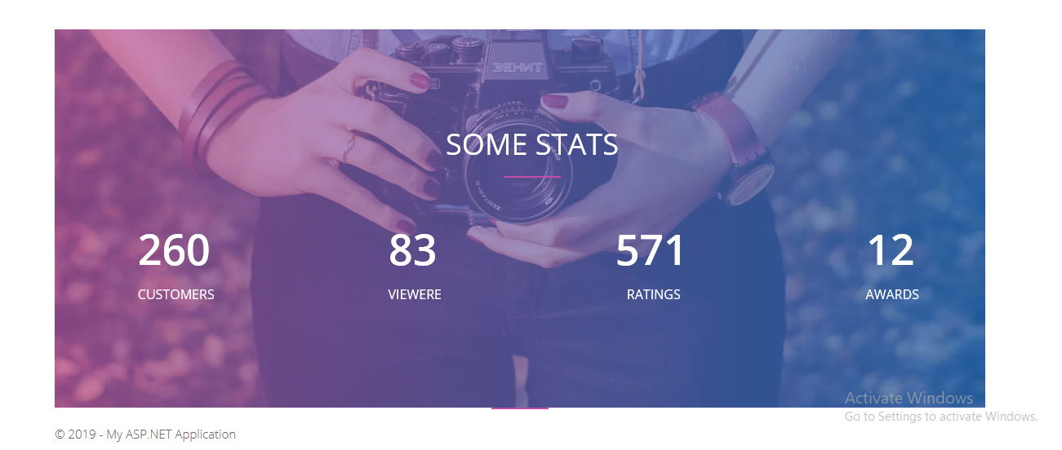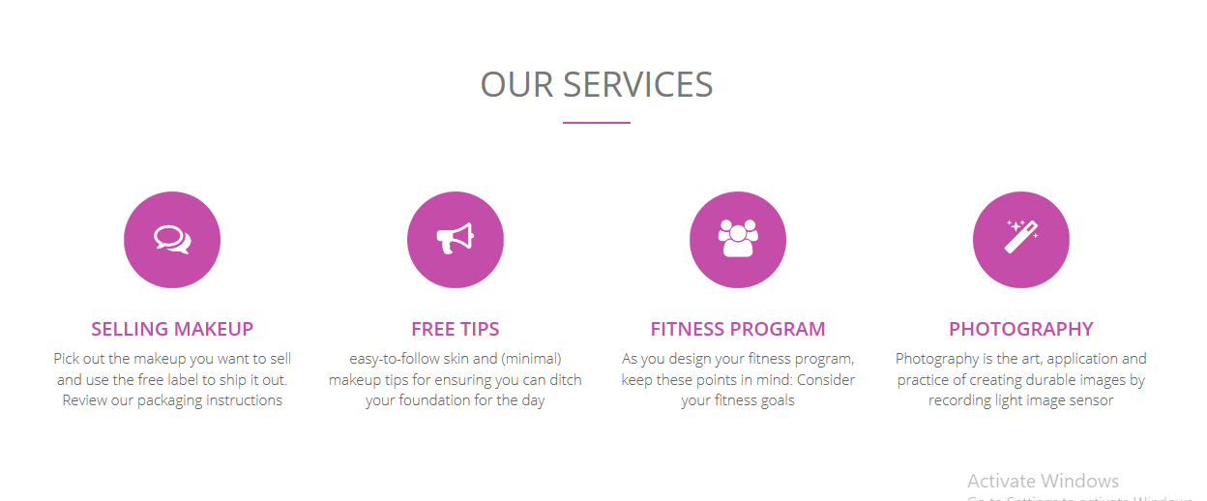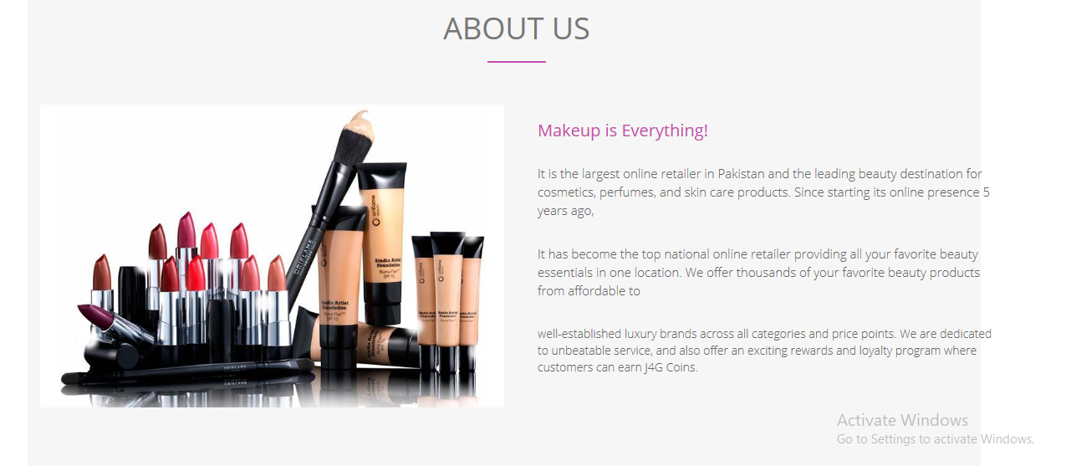

* 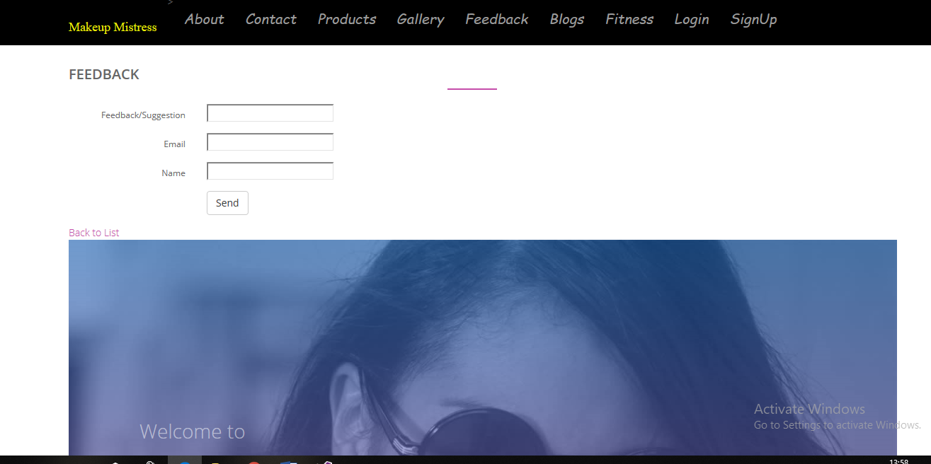**feedback**
* **products**

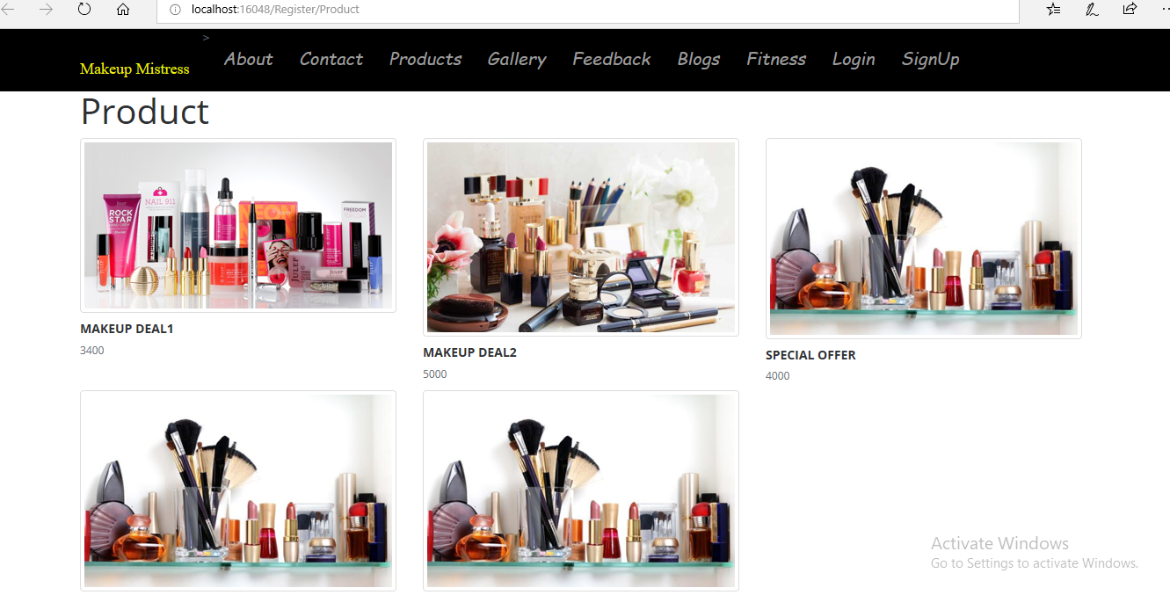

* 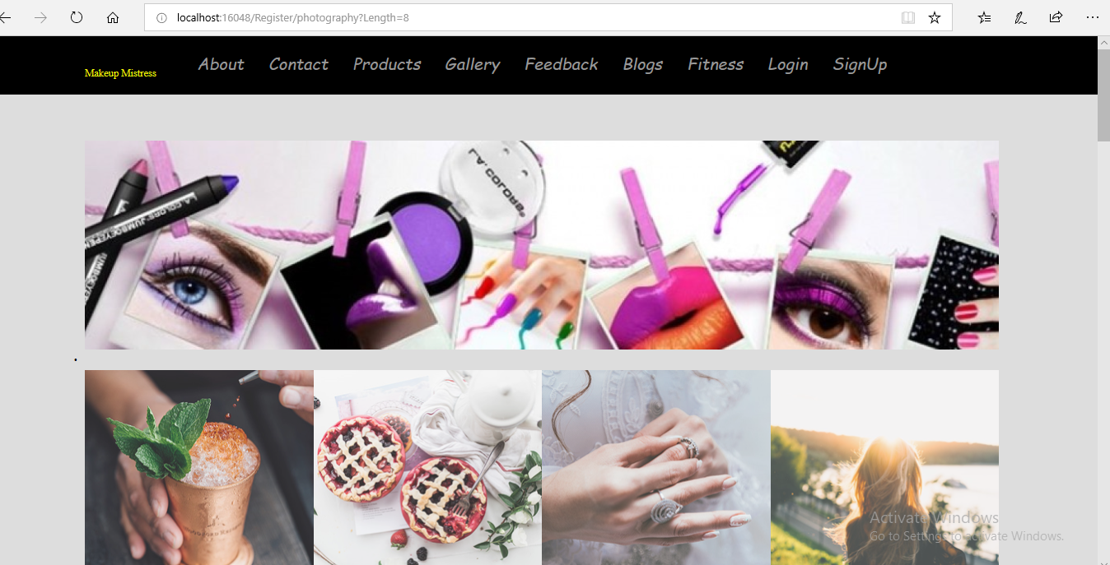**gallery**
* 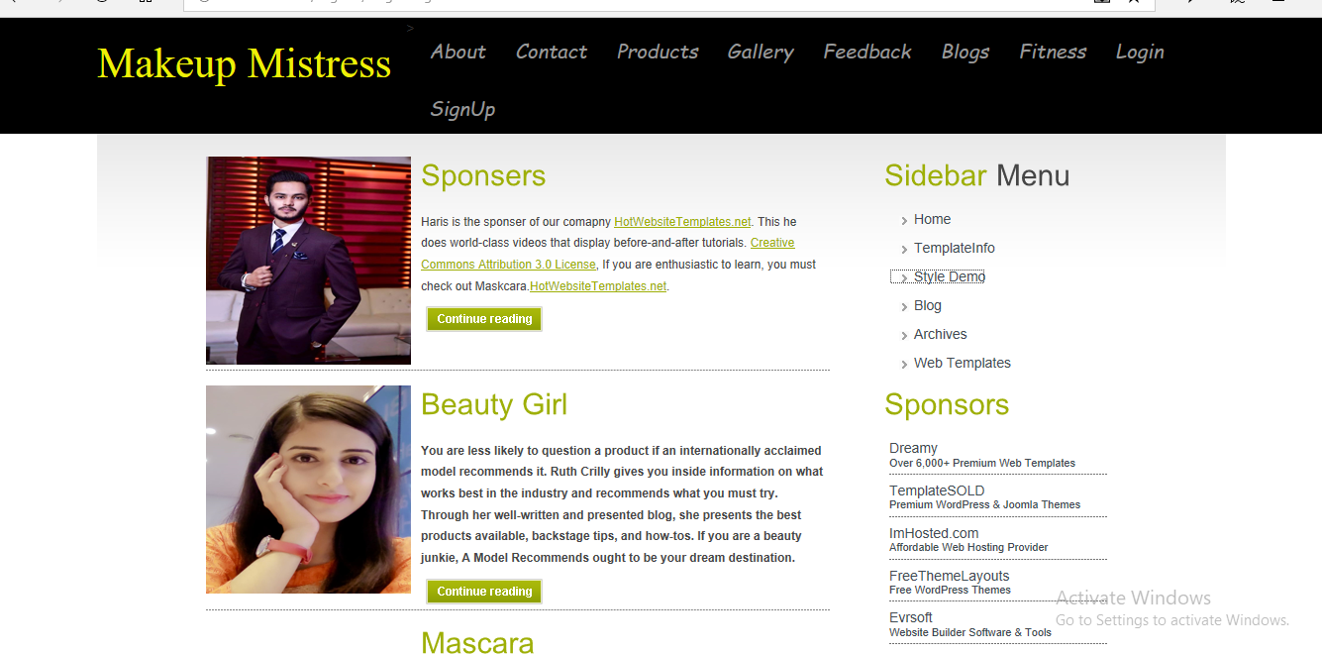**blogs**

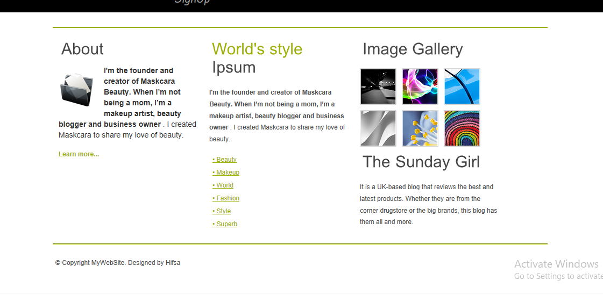

* **fitness**

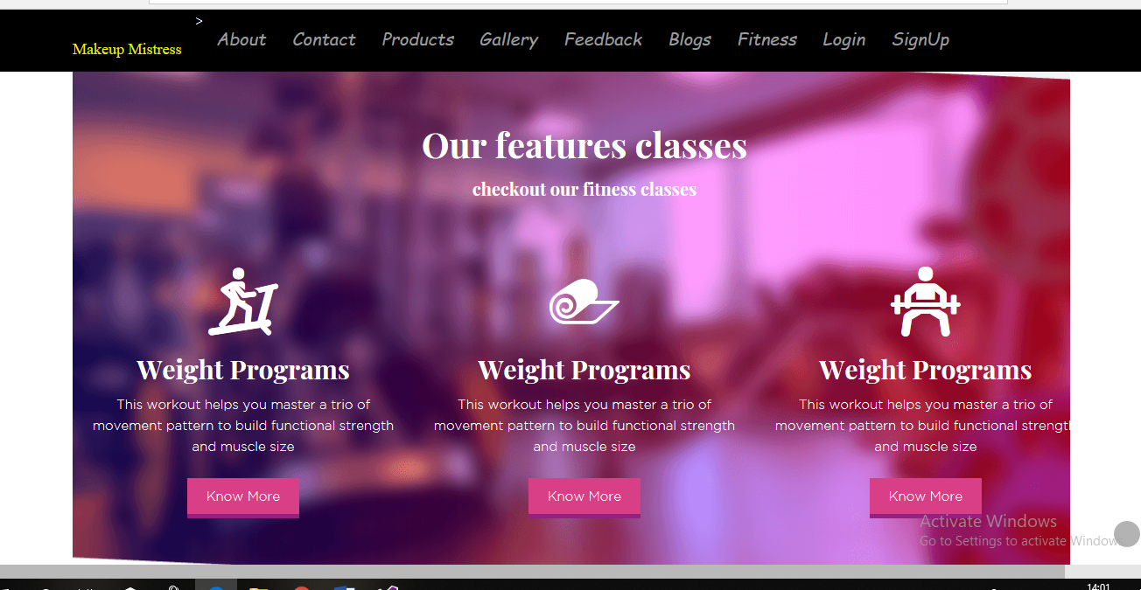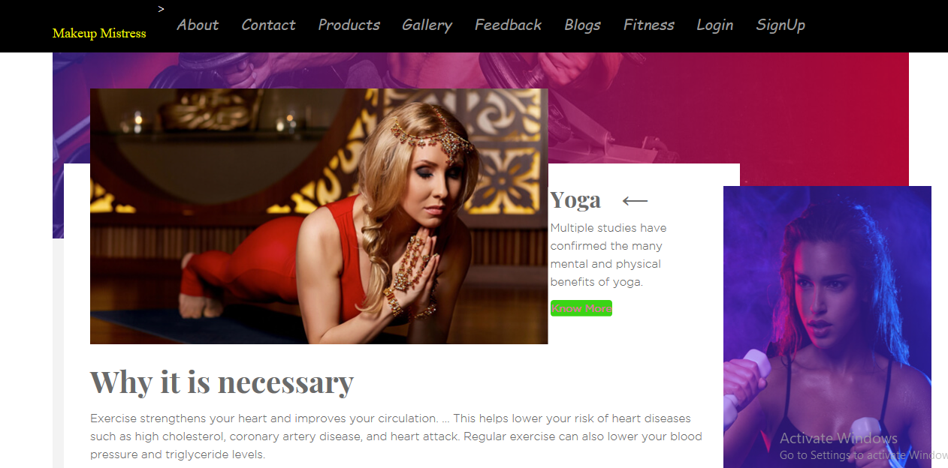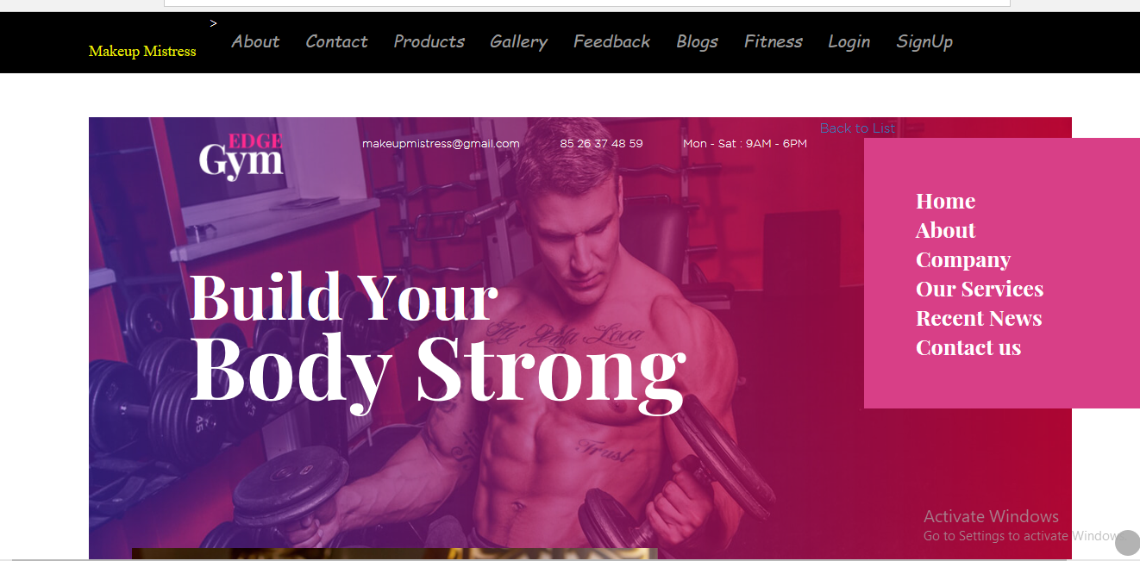

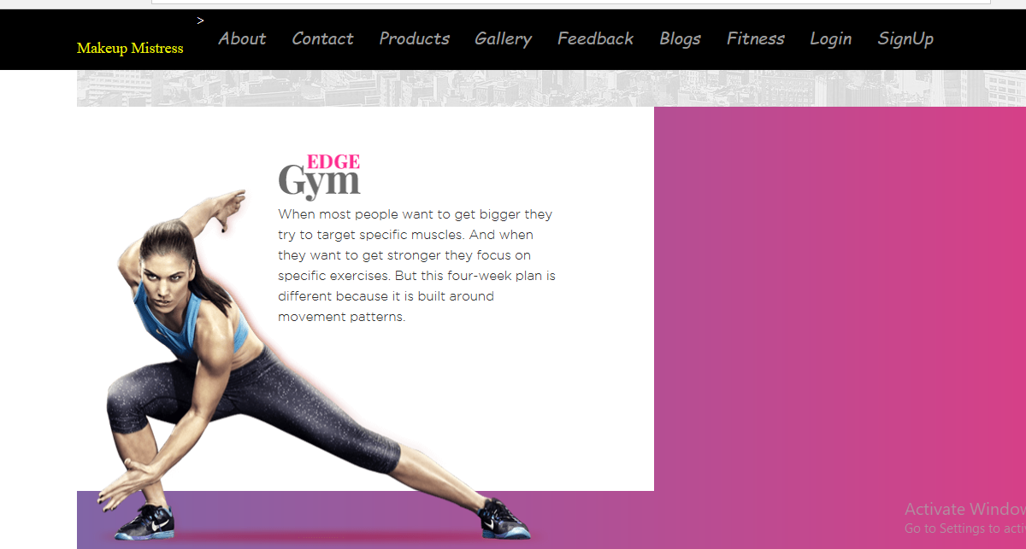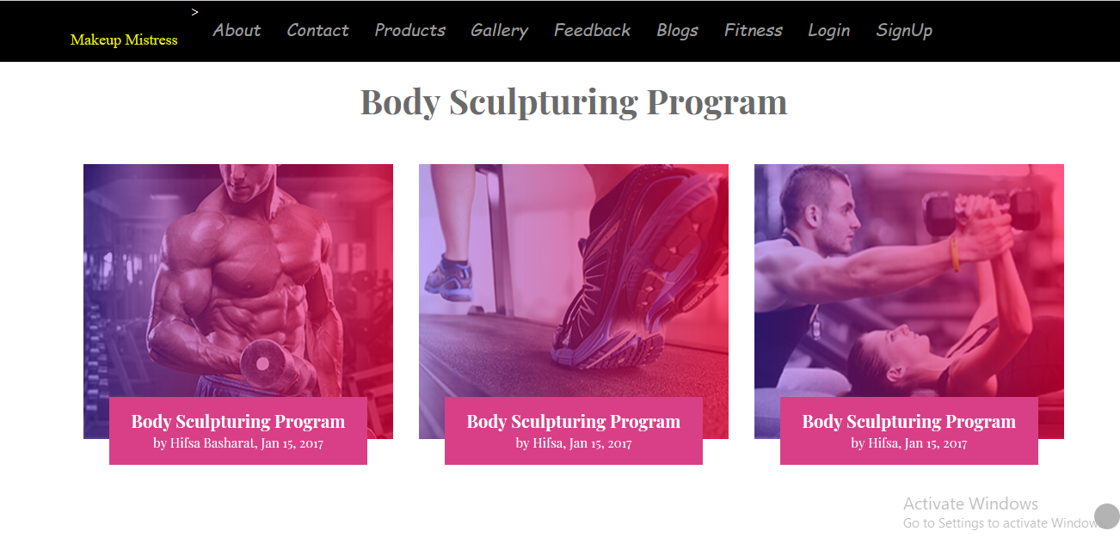

* 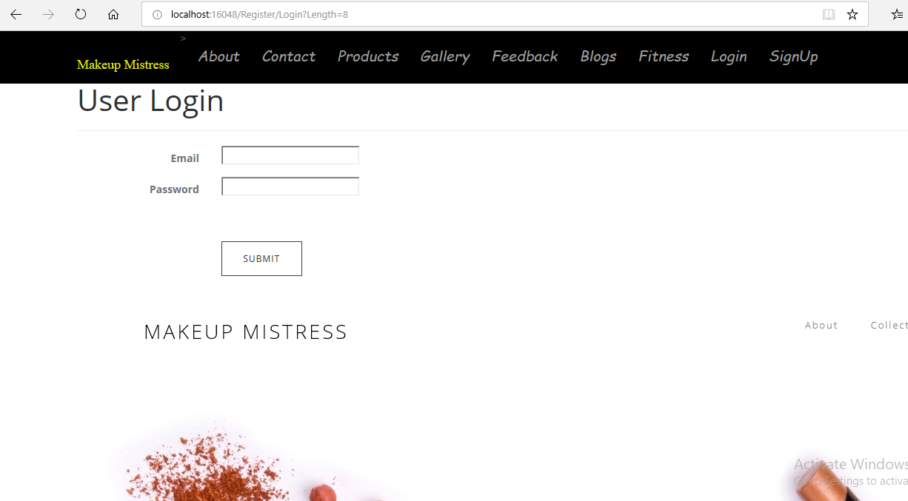**login**
* 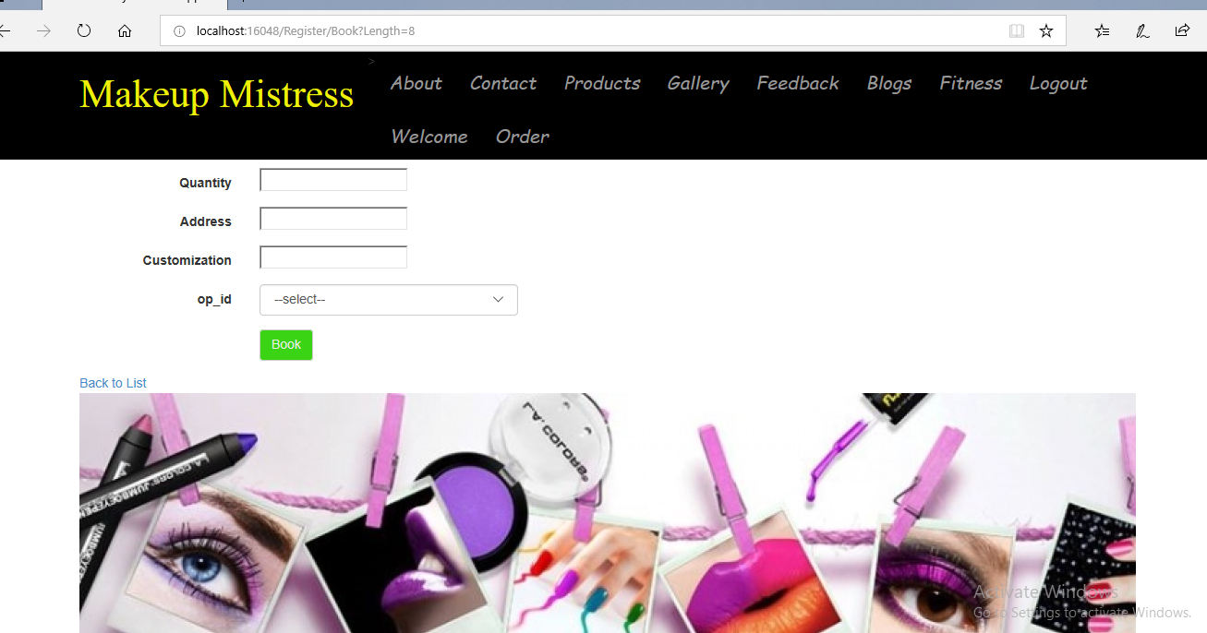**order product**

**CODING**

**Modals**

* **TBL_USER**

public partial class TBL_USER

{ public int u_id { get; set; }

[Display(Name="Name")]

[Required(ErrorMessage="*")]

public string u_name { get; set; }

[Display(Name = "Email")]

[Required(ErrorMessage = "*")]

[RegularExpression(@"(@"^([a-zA-Z0-9_\-\.]+)@([a-zA-Z0-9_\-\.]+)\.([a-zA-Z]{2,5})$", ",ErrorMessage="invalid format")]

public string u_email { get; set; }

[Display(Name = "Contact")]

[Required(ErrorMessage = "*")]

public string u_contact { get; set; }

[Display(Name = "Password")]

[Required(ErrorMessage = "*")]

public string u_password { get; set; }

[Display(Name = "Subscription Type")]

[Required(ErrorMessage = "*")]

public Nullable<int> u_subs { get; set; }

public virtual TBL_MEMBERSHIP TBL_MEMBERSHIP { get; set; }

}

}

* **TBL_PRODUCT**

public partial class TBL_PRODUCT

{public TBL_PRODUCT()

{

this.TBL_ORDER = new HashSet<TBL_ORDER>();

}

public int pr_id { get; set; }

[Display(Name = "Product Name")]

[Required(ErrorMessage = "*")]

public string pr_name { get; set; }

[Display(Name = "Product Imaage")]

[Required(ErrorMessage = "*")]

public string pr_image { get; set; }

[Display(Name = "Product Price")]

[Required(ErrorMessage = "*")]

public int pr_price { get; set; }

public HttpPostedFileBase ImageFile { get; set; }

public virtual ICollection<TBL_ORDER> TBL_ORDER { get; set; }

}

}

* **TBL_ORDER**

public partial class TBL_ORDER

{ public int o_id { get; set; }

[Display(Name = "Quantity")]

[Required(ErrorMessage = "*")]

public int quantity { get; set; }

[Display(Name = "Address")]

[Required(ErrorMessage = "*")]

public string o_address { get; set; }

[Display(Name = "Customization")]

[Required(ErrorMessage = "*")]

public string o_custom { get; set; }

[Display(Name = "Product Name")]

[Required(ErrorMessage = "*")]

public Nullable<int> op_id { get; set; }

public virtual TBL_PRODUCT TBL_PRODUCT { get; set; }

}

}

* **TBL_FEEDBACK**

public partial class TBL_FEEDBACK

{ public int f_id { get; set; }

[Display(Name = "Feedback/Suggestion")]

[Required(ErrorMessage = "*")]

public string f_text { get; set; }

[Display(Name = "Email")]

[Required(ErrorMessage = "*")]

[RegularExpression(@"^([a-zA-Z0-9_\-\.]+)@([a-zA-Z0-9_\-\.]+)\.([a-zA-Z]{2,5})$", ErrorMessage = "invalid format")]

public string f_email { get; set; }

[Display(Name = "Name")]

[Required(ErrorMessage = "*")]

public string f_name { get; set; }

}

}

**CONTROLLERS**

* **REGISTER CONTROLLER**

public class RegisterController : Controller

{ vpEntities db = new vpEntities();

public ActionResult Index()

{

return View();

}

public ActionResult photography()

{

return View();

}

public ActionResult blogs()

{

return View();

}

public ActionResult Tips()

{

return View();

}

public ActionResult About()

{

return View();

}

public ActionResult magazine()

{

return View();

}

public ActionResult apply()

{

return View();

}

[HttpGet]

public ActionResult Register()

{List<TBL_MEMBERSHIP> li = db.TBL_MEMBERSHIP.ToList();

ViewBag.list = new SelectList(li, "MEM_ID ", "MEM_TYPE ");

return View();

}

[HttpPost]

public ActionResult Register(TBL_USER u)

{try

{List<TBL_MEMBERSHIP> li = db.TBL_MEMBERSHIP.ToList();

ViewBag.list = new SelectList(li, "MEM_ID ", "MEM_TYPE ");

//db.TBL_USER.Add(u);

//db.SaveChanges();

TBL_USER ur = new TBL_USER();

ur.u_name = u.u_name;

ur.u_email = u.u_email;

ur.u_contact = u.u_contact;

ur.u_password = u.u_password;

ur.u_subs = u.u_subs;

db.TBL_USER.Add(ur);

db.SaveChanges();

return RedirectToAction("AfterSignup");

}

catch(Exception)

{//throw;

}

return View();

}//end

[HttpGet]

public ActionResult Book()

{List<TBL_PRODUCT> li = db.TBL_PRODUCT.ToList();

ViewBag.list = new SelectList(li, "pr_id", "pr_name");

return View();

} [HttpPost]

public ActionResult Book(TBL_ORDER u)

{try

{List<TBL_PRODUCT> li = db.TBL_PRODUCT.ToList();

ViewBag.list = new SelectList(li, "pr_id", "pr_name");

//db.TBL_USER.Add(u);

//db.SaveChanges();

TBL_ORDER ur = new TBL_ORDER();

ur.o_id = u.o_id;

ur.o_address = u.o_address;

ur.o_custom = u.o_custom;

ur.op_id = u.op_id;

ur.quantity = u.quantity;

db.TBL_ORDER.Add(ur);

db.SaveChanges();

return View();

}catch (Exception)

{//throw;

}

return View();

}//end

[HttpGet]

public ActionResult Login()

{

return View();

} [HttpGet]

public ActionResult Logout()

{Session.Abandon();

Session.RemoveAll();

return RedirectToAction("Login");

} [HttpPost]

public ActionResult Login(TBL_USER u)

{TBL_USER ui = db.TBL_USER.Where(x => x.u_email == u.u_email && x.u_password == u.u_password).SingleOrDefault();

if (ui != null)

{Session["u_id"] = ui.u_id;

return RedirectToAction("UserPanel");

}else

{ViewBag.error = "Invalid Email or password.....";

}

return View();

} [HttpGet]

public ActionResult UserPanel()

{if(Session["u_id"]==null)

{return RedirectToAction("Login");

}

return View();}

[HttpGet]

public ActionResult Contact()

{return View();

} [HttpPost]

public ActionResult Contact(TBL_FEEDBACK fed)

{

TempData["msg"] = null;

try

{db.TBL_FEEDBACK.Add(fed);

db.SaveChanges();

TempData["msg"] = "Your message is submitted";

TempData.Keep();

return RedirectToAction("Contact");

}catch (Exception)

{return RedirectToAction("Errorpage");

//throw;

}

}

public ActionResult Errorpage()

{return View();

}

public ActionResult Product()

{return View(db.TBL_PRODUCT.ToList());

}

public ActionResult AfterSignup()

{return View();

}

}}

* **ADMIN_CONTROLLER**

public class AdminController : Controller

{vpEntities db = new vpEntities();

public ActionResult Index()

{return View();

}

public ActionResult CustomerList()

{return View(db.TBL_USER.ToList().OrderByDescending(x => x.u_id));

}

public ActionResult CustomerOrder()

{return View(db.TBL_ORDER.ToList().OrderByDescending(x => x.o_id));

}

public ActionResult FeedBack()

return View(db.TBL_FEEDBACK.ToList().OrderByDescending(x => x.f_id));

}

[HttpGet]

public ActionResult AddProduct()

{return View();

}

[HttpPost]

public ActionResult AddProduct(TBL_PRODUCT imageModel)

{string fileName = Path.GetFileNameWithoutExtension(imageModel.ImageFile.FileName);

string extension = Path.GetExtension(imageModel.ImageFile.FileName);

fileName = fileName + DateTime.Now.ToString("yymmssfff") + extension;

imageModel.pr_image = "~/Images/" + fileName;

fileName = Path.Combine(Server.MapPath("~/Images/"), fileName);

imageModel.ImageFile.SaveAs(fileName);

using (vpEntities db = new vpEntities())

{db.TBL_PRODUCT.Add(imageModel);

db.SaveChanges();

} ModelState.Clear();

return View();

}

}}

**VIEWS**

* **ADD PRODUCT.CSHTML**

@model Makeup.Models.TBL_PRODUCT

@{

ViewBag.Title = "AddProduct";

Layout = "~/Views/Shared/_Layoutadmin.cshtml";

} @using (Html.BeginForm("AddProduct", "Admin", FormMethod.Post, new { enctype = "multipart/form-Data" }))

{@Html.AntiForgeryToken()

<div class="form-horizontal">

@Html.ValidationSummary(true)

<div class="form-group">

@Html.LabelFor(model => model.pr_name, new { @class = "control-label col-md-2" })<div class="col-md-10">

@Html.EditorFor(model => model.pr_name)

@Html.ValidationMessageFor(model => model.pr_name)

</div>

</div>

<div class="form-group">

@Html.LabelFor(model => model.pr_image, new { @class = "control-label col-md-2" })<div class="col-md-10">

<input type="file" name="ImageFile" required />

</div> </div>

<div class="form-group">

@Html.LabelFor(model => model.pr_price, new { @class = "control-label col-md-2" })<div class="col-md-10">

@Html.EditorFor(model => model.pr_price)

@Html.ValidationMessageFor(model => model.pr_price)<div/></div>

* **VIEW CUSTOMER.CSHTML**

@model IEnumerable<Makeup.Models.TBL_USER>

@{ViewBag.Title = "CustomerList";

Layout = "~/Views/Shared/_Layoutadmin.cshtml";

} @Html.ActionLink("Create New", "Create")

</p><table class="table">

<tr><th>

@Html.DisplayNameFor(model => model.u_name)

</th><th>

@Html.DisplayNameFor(model => model.u_email)

</th><th>

@Html.DisplayNameFor(model => model.u_contact)

</th> <th>

@Html.DisplayNameFor(model => model.u_password)

</th><th>

@Html.DisplayNameFor(model => model.TBL_MEMBERSHIP.MEM_TYPE)

</th>

<th></th>

@foreach (var item in Model)

{<tr> <td>

@Html.DisplayFor(modelItem => item.u_name)

</td> <td>

@Html.DisplayFor(modelItem => item.u_email)

</td> <td>

@Html.DisplayFor(modelItem => item.u_contact)

</td> <td>

@Html.DisplayFor(modelItem => item.u_password)

</td> <td>

@Html.DisplayFor(modelItem => item.TBL_MEMBERSHIP.MEM_TYPE)

</td><td>

@Html.ActionLink("Edit", "Edit", new { id = item.u_id }) |

@Html.ActionLink("Details", "Details", new { id = item.u_id }) |

@Html.ActionLink("Delete", "Delete", new { id = item.u_id })

</td>

</tr>

</table>

* **VIEW CUSTOMER FEEDBACK.CSHTML**

@model IEnumerable<Makeup.Models.TBL_FEEDBACK>

@{ViewBag.Title = "FeedBack";

Layout = "~/Views/Shared/_Layoutadmin.cshtml";

}<h2>FeedBack</h2>

<p>@Html.ActionLink("Create New", "Create")

</p>

<table class="table">

<tr><th>@Html.DisplayNameFor(model => model.f_text)

</th>

<th>

@Html.DisplayNameFor(model => model.f_email)

</th>

<th>@Html.DisplayNameFor(model => model.f_name)

</th>

<th></th>

</tr>

@foreach (var item in Model)

{<tr><td> @Html.DisplayFor(modelItem => item.f_text)

</td> <td>

@Html.DisplayFor(modelItem => item.f_email)

</td> <td>

@Html.DisplayFor(modelItem => item.f_name)

</td> <td>

@Html.ActionLink("Edit", "Edit", new { id = item.f_id }) |

@Html.ActionLink("Details", "Details", new { id = item.f_id }) |

@Html.ActionLink("Delete", "Delete", new { id = item.f_id })

</td>

</tr>}

</table>

**SHARED FOLDER**

* **_LAYOUT.CSHTML**

<!DOCTYPE html>

<html>

<head>

<title>@Page.Title</title>

@RenderSection("head", required: false)

<link rel="stylesheet" href="https://maxcdn.bootstrapcdn.com/bootstrap/3.3.7/css/bootstrap.min.css">

<meta charset="utf-8" />

<meta name="viewport" content="width=device-width, initial-scale=1.0">

<title>@ViewBag.Title - My ASP.NET Application</title>

@Styles.Render("~/Content/css")

@Scripts.Render("~/bundles/modernizr")

</head>

<body>div class="navbar navbar-inverse navbar-fixed-top">

<div class="container">

<div class="navbar-header">

<button type="button" class="navbar-toggle" data-toggle="collapse" data-target=".navbar-collapse">

<span class="icon-bar"></span>

<span class="icon-bar"></span>

<span class="icon-bar"></span>

@*@Html.ActionLink("'", "Index", "Home", null)*@

<div class="navbar-collapse collapse">

<ul class="nav navbar-nav">

<li>>@Html.ActionLink("Makeup Mistress", "Index", "Register", new { @class = "navbar-brand" })</li>

<li>@Html.ActionLink("About", "About", "Register", new { @class = "navbar-br" })</li>

<li>@Html.ActionLink("Contact", "Contact", "Register", new { @class = "navbar-br" })</li>

<li>@Html.ActionLink("Products", "Product", "Register", new { @class = "navbar-br" })</li>

<li>@Html.ActionLink("Gallery", "photography", "Register", new { @class = "navbar-br" })</li>

<li>@Html.ActionLink("Feedback", "Contact", "Register", new { @class = "navbar-br" })</li>

<li>@Html.ActionLink("Blogs", "blogs", "Register", new { @class = "navbar-br" })</li>

<li>@Html.ActionLink("Fitness", "Tips", "Register", new { @class = "navbar-br" })</li>

@if(Session["u_id"]==null)

{

<li>@Html.ActionLink("Login", "Login", "Register", new { @class = "navbar-br" })</li>

<li>@Html.ActionLink("SignUp", "Register", "Register", new { @class = "navbar-br" })</li>

}else

{

<li>@Html.ActionLink("Logout", "Logout", "Register", new { @class = "navbar-br" })</li>

<li>@Html.ActionLink("Welcome", "UserPanel", "Register", new { @class = "navbar-br" })</li>

<li>@Html.ActionLink("Order", "Book", "Register", new { @class = "navbar-br" })</li>

}

<div class="container body-content">

@RenderBody()

<hr />

<footer>

<p>&copy; @DateTime.Now.Year - My ASP.NET Application</p>

</footer>

</div>

@Scripts.Render("~/bundles/jquery")

@Scripts.Render("~/bundles/bootstrap")

@RenderSection("scripts", required: false)

</body>

</html>

* **_LAYOUTADMIN.CSHTML**

<!DOCTYPE html>

<html>

<head>

<title>@Page.Title</title>

@RenderSection("head", required: false)

@*<link rel="stylesheet" href="https://maxcdn.bootstrapcdn.com/bootstrap/3.3.7/css/bootstrap.min.css">*@

<link href="~/Content/bootstrap.css" rel="stylesheet" />

<meta charset="utf-8" />

<meta name="viewport" content="width=device-width, initial-scale=1.0">

<title>@ViewBag.Title - My ASP.NET Application</title>

@Styles.Render("~/Content/css")

@Scripts.Render("~/bundles/modernizr")

</head>

<body><div class="navbar navbar-inverse navbar-fixed-top">

<div class="container">

<div class="navbar-header">

<button type="button" class="navbar-toggle" data-toggle="collapse" data-target=".navbar-collapse">

<span class="icon-bar"></span>

<span class="icon-bar"></span>

<span class="icon-bar"></span>

</button>

@*@Html.ActionLink("'", "Index", "Home", null)*@

<div class="navbar-collapse collapse">

<ul class="nav navbar-nav">

<li>>@Html.ActionLink("ADMINISTRATION", "", "", new { @class = "navbar-brand" })</li>

<li>@Html.ActionLink("Add Products", "AddProduct", "Admin", new { @class = "list-group-item" })</li>

<li>@Html.ActionLink("View Feedback", "Feedback", "Admin", new { @class = "list-group-item" })</li>

<li> @Html.ActionLink("View Orders", "CustomerOrder", "Admin", new { @class = "list-group-item" })</li>

<li> @Html.ActionLink("View Users", "CustomerList", "Admin", new { @class = "list-group-item" })</li>

</div>

<div class="container body-content">

@RenderBody()

<hr />

<footer>

<p>&copy; @DateTime.Now.Year - My ASP.NET Application</p>

</footer>

@Scripts.Render("~/bundles/jquery")

@Scripts.Render("~/bundles/bootstrap")

@RenderSection("scripts", required: false)

</body>

</html>